CS299 INNOVATION LAB

# Complaint Management System for Shops

**Project by**: Bhanwar Yuvraj Singh Nathawat, 2001CS17

**Under the mentorship of** Dr. SAMRAT MONDAL, Associate Professor IIT Patna

**Submitted on**: 1/05/2022

**INTRODUCTION**

In this project, I made a portal on which all complaints regarding shops present on our campus will be managed and tracked.

In this project, we have three types of users

first student or any employee who can complain

second admin who will keep track of all complaints and users

third shop owners.

**Motivation**

There may be some institutions where that don't have a proper

complaint registration and resolving system, so for them my complaint management system will be helpful.

**Languages used:**

* Html
* Php
* Javascript
* Mysql for database

**Approach:**

* Initially, I learned the basics of PHP for this project and went through some complaint management systems available on the internet.
* Then I learned some basics of MySQL like queries to create tables, update, alter, etc.
* Then I learned to build connections between PHP and MySQL.
* After that, I started writing code for the front end.
* And on further instructions given by Sir Samrat Mondal on the weekly basis, I upgraded my portal and added some new features, now it is fully functional and secured.

**Project description**

* On the first we have an index having three options such as:

1. User
2. Admin
3. shop owner

* On clicking on any of them you will get a login page having a username and password field to log in

and create an account option for user only not for admin and shop owners in order to make the portal secure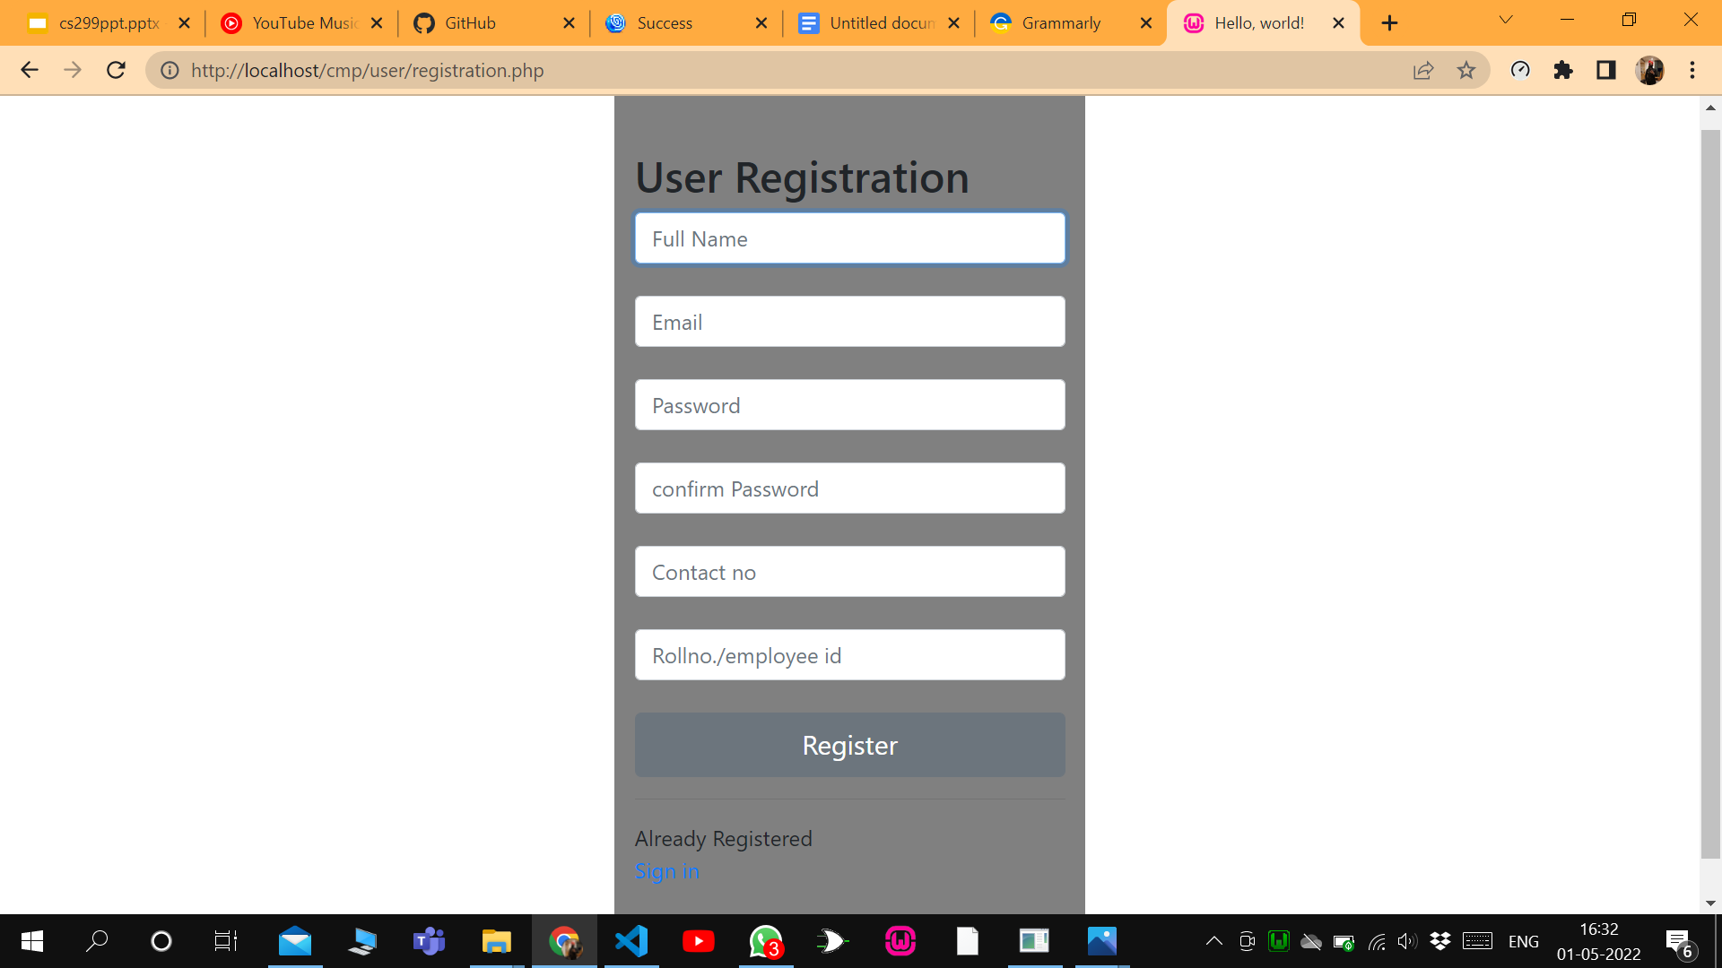

And forgot the password option to reset your password.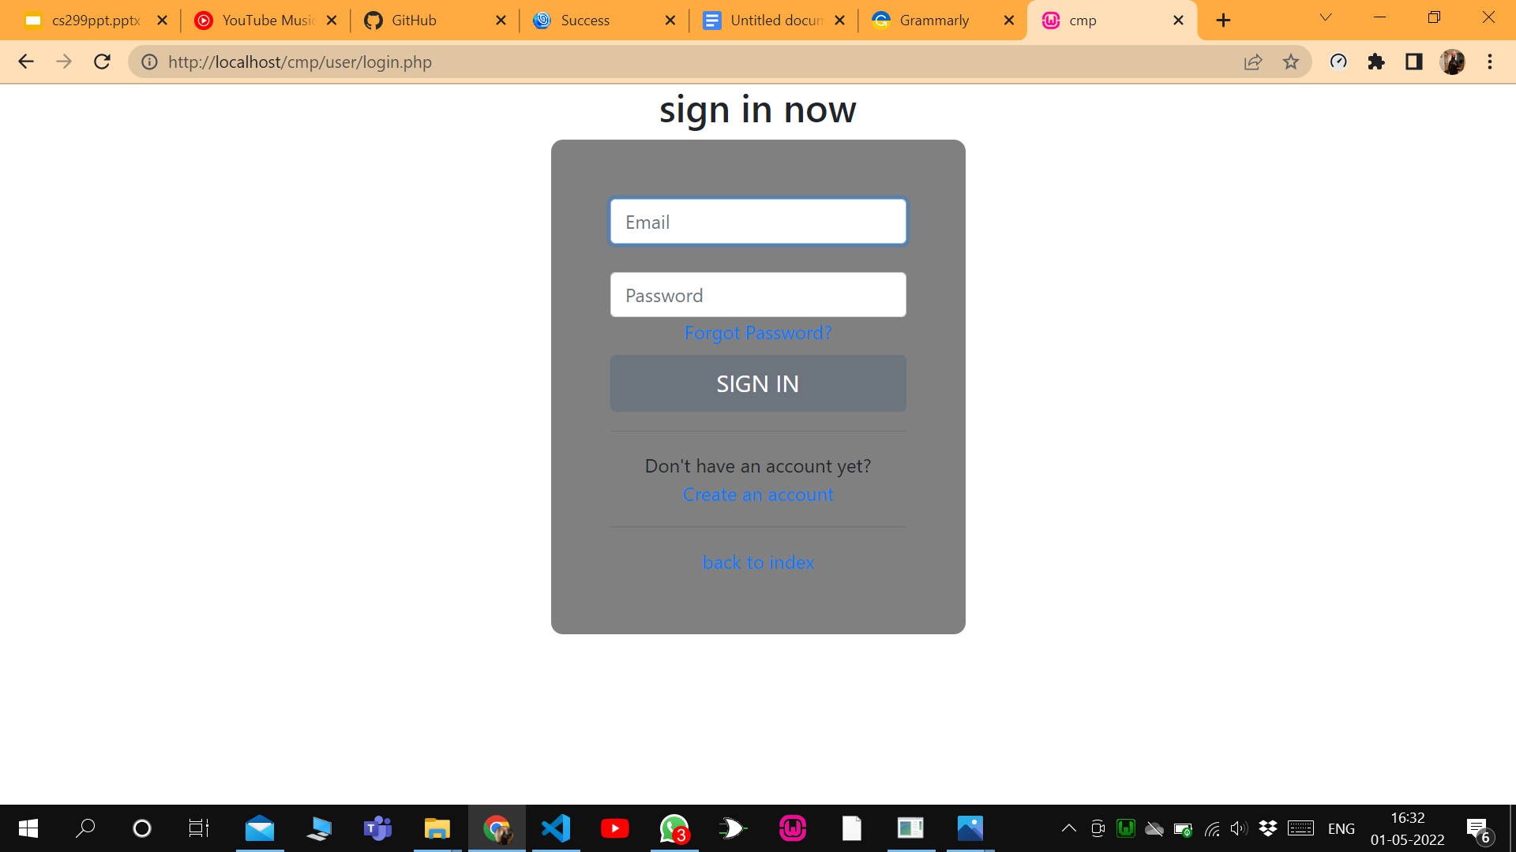

* After successful login, you will reach an index page mentioning features available to a particular kind of user.
* Features for user

1. Registering complaint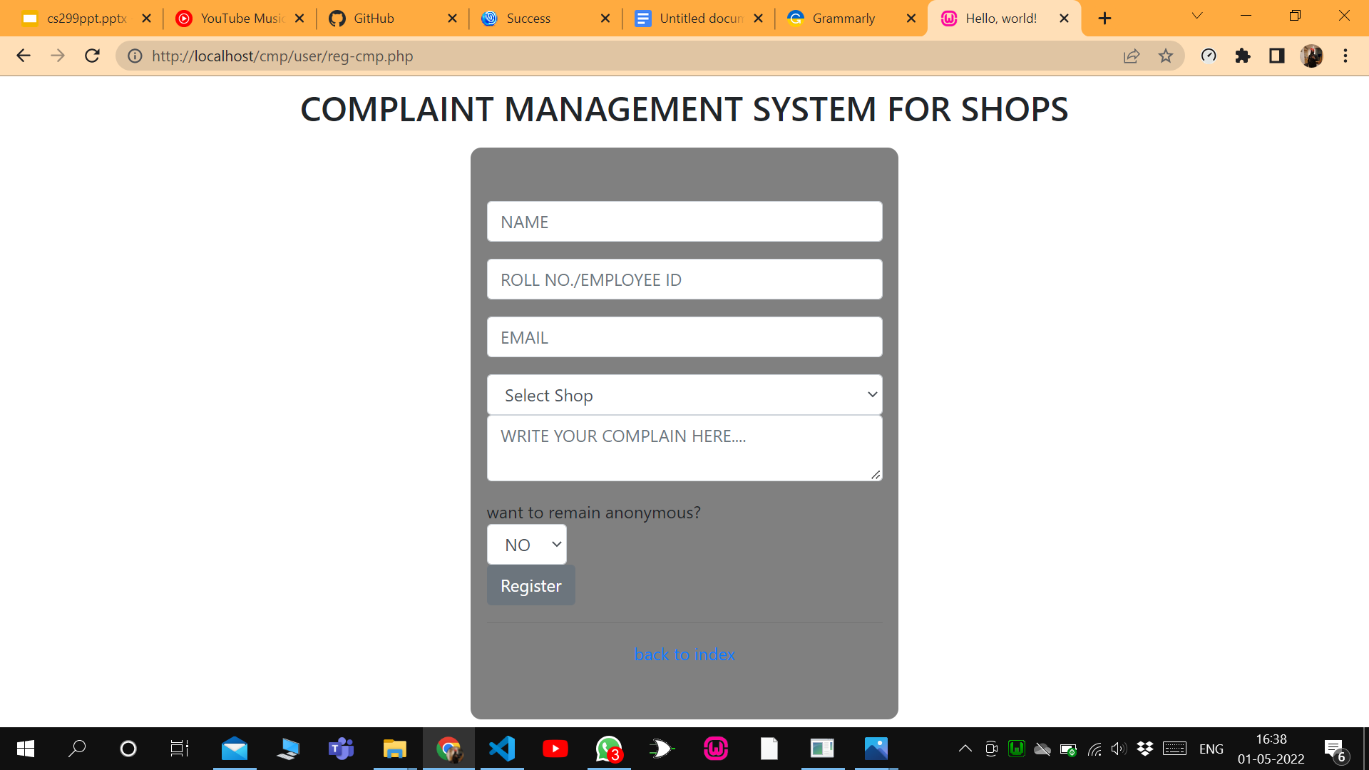
2. Change password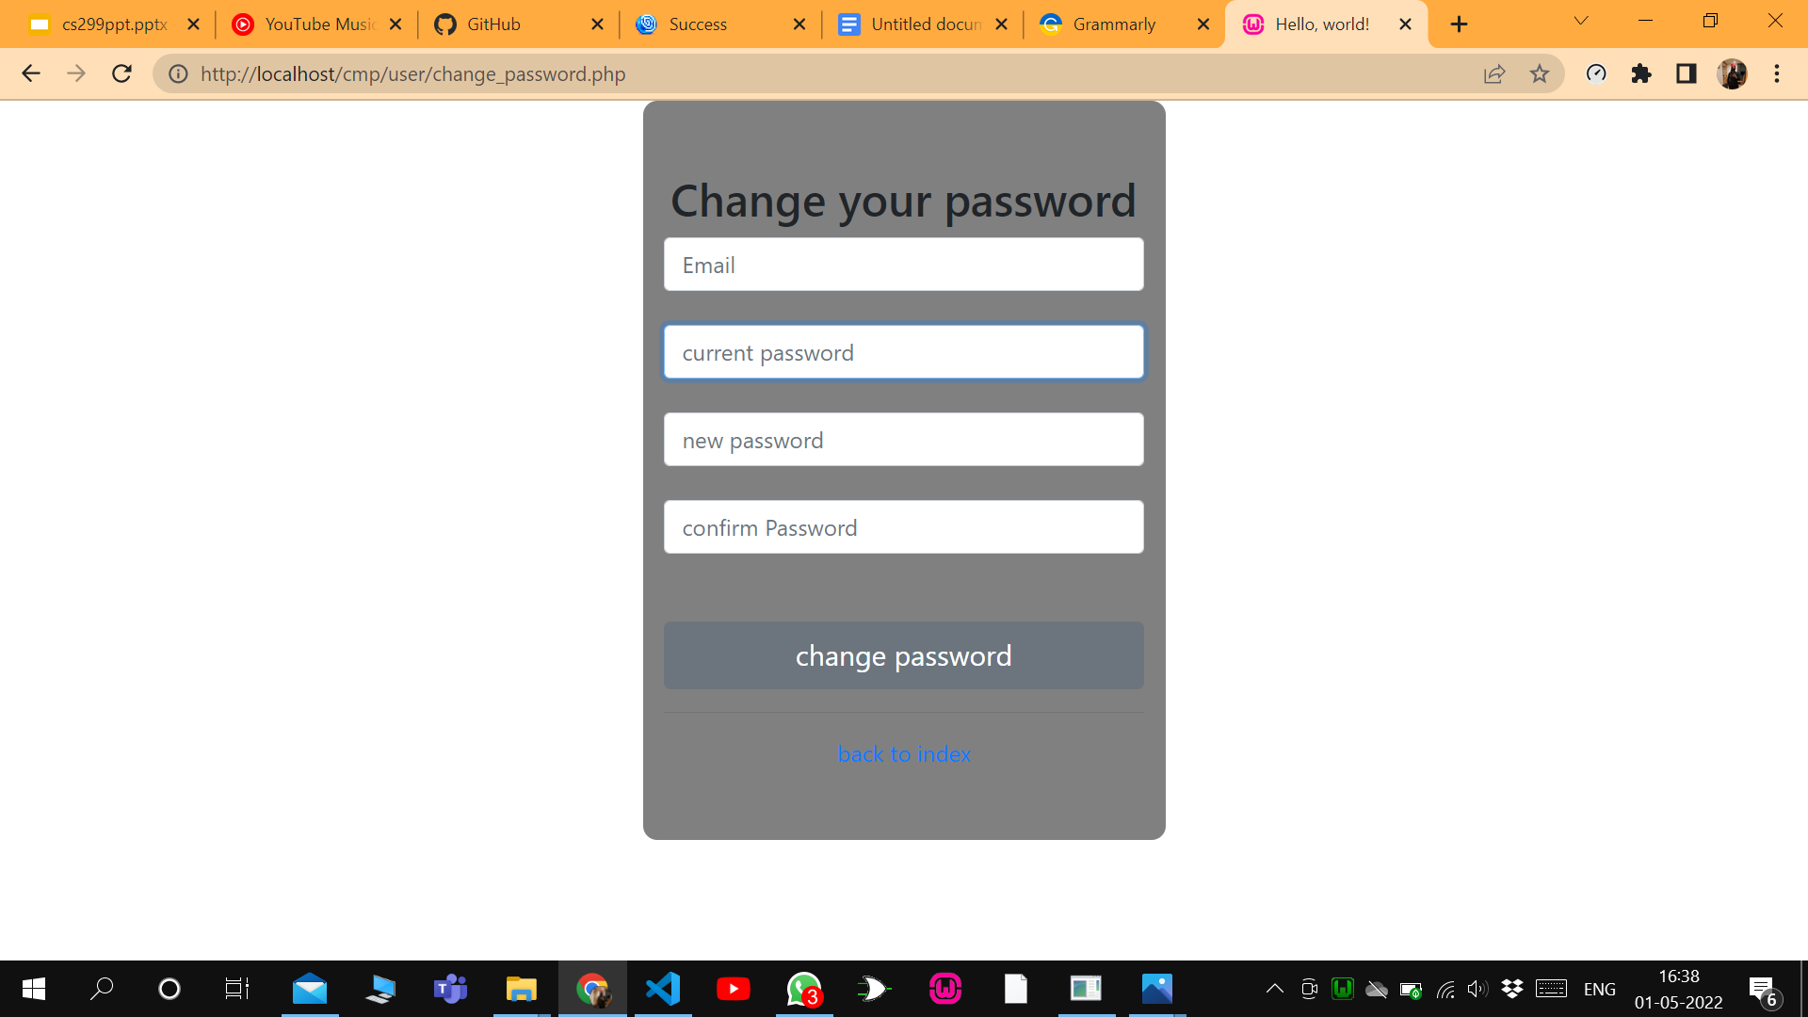
3. track complaint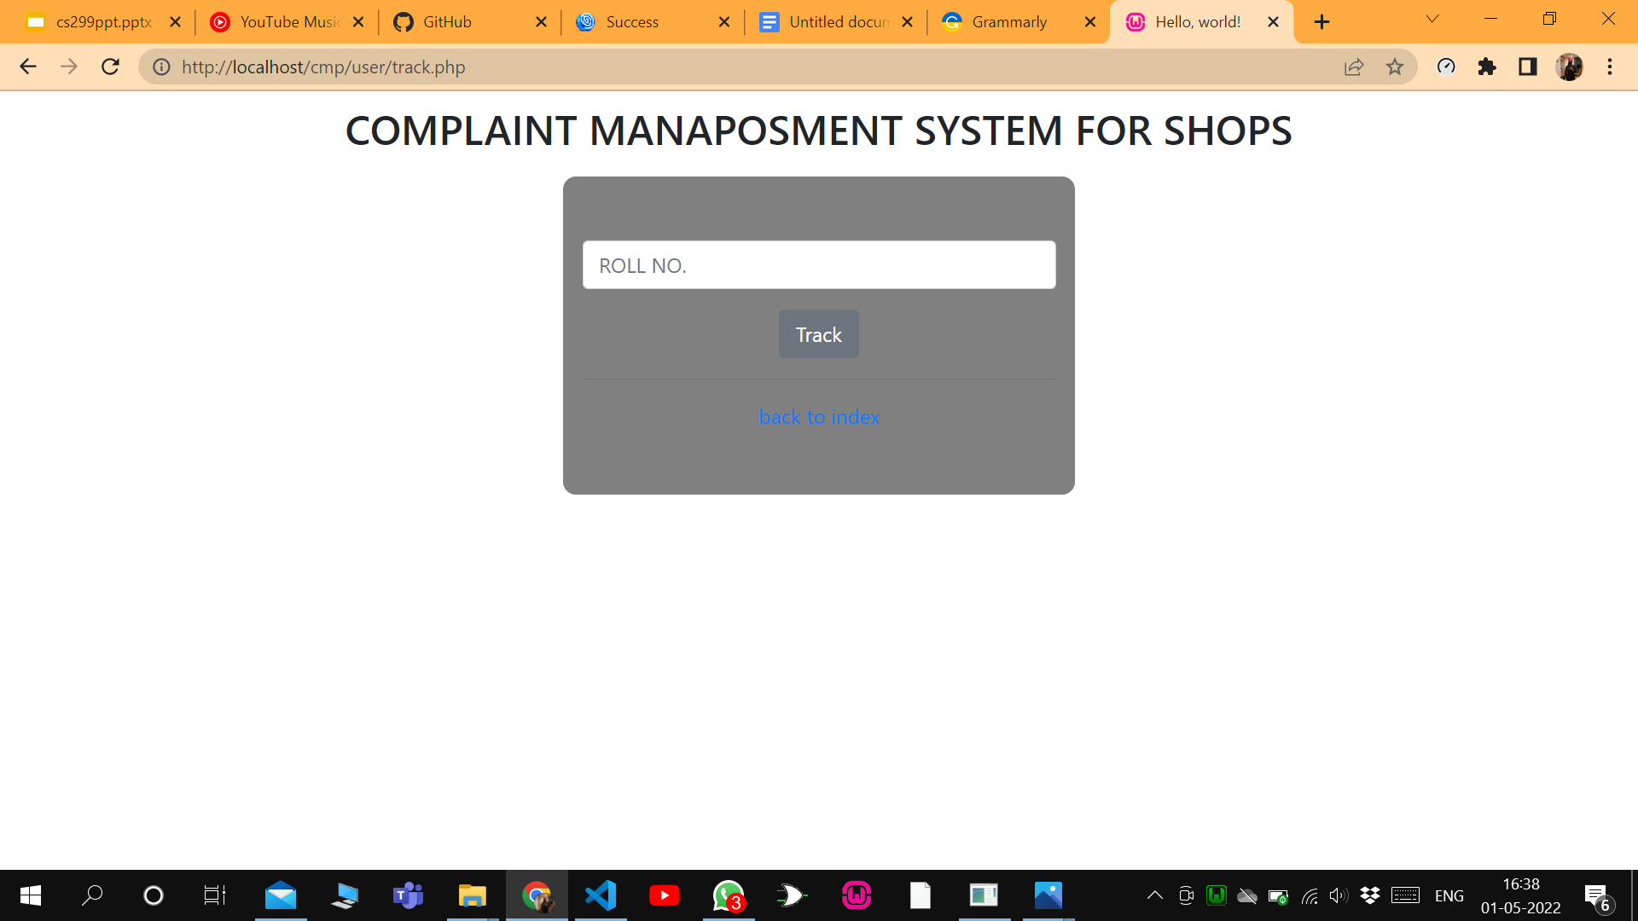

* Features for admin

1. Add Shop details(to add new shops)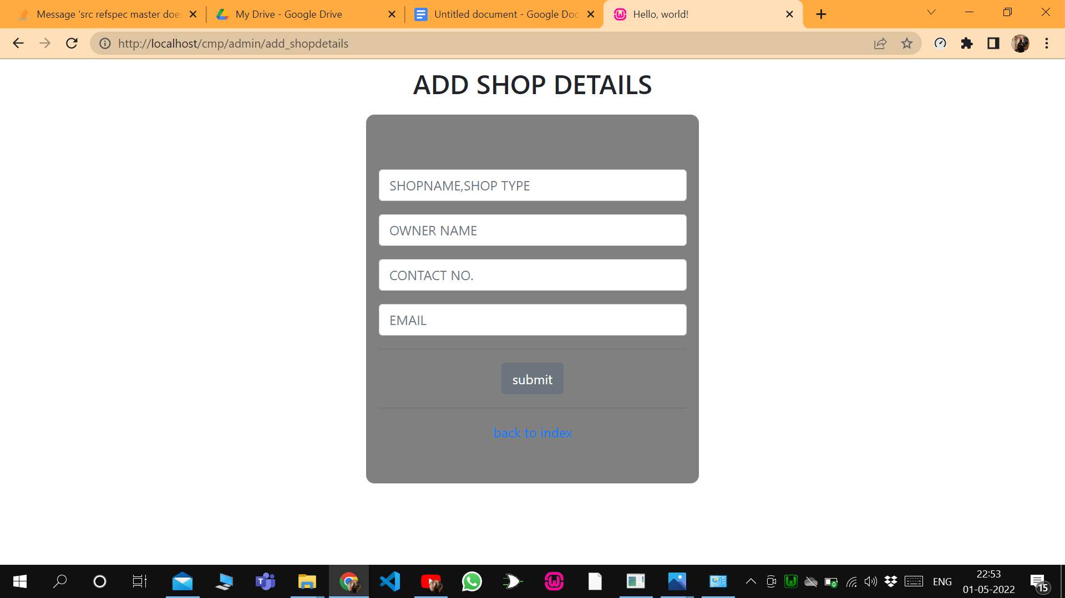
2. Change password
3. Direct MySQL query(for any special case)
4. View complaints(sorting of complaints on the basis of time, shop, roll no./employee id of complainer)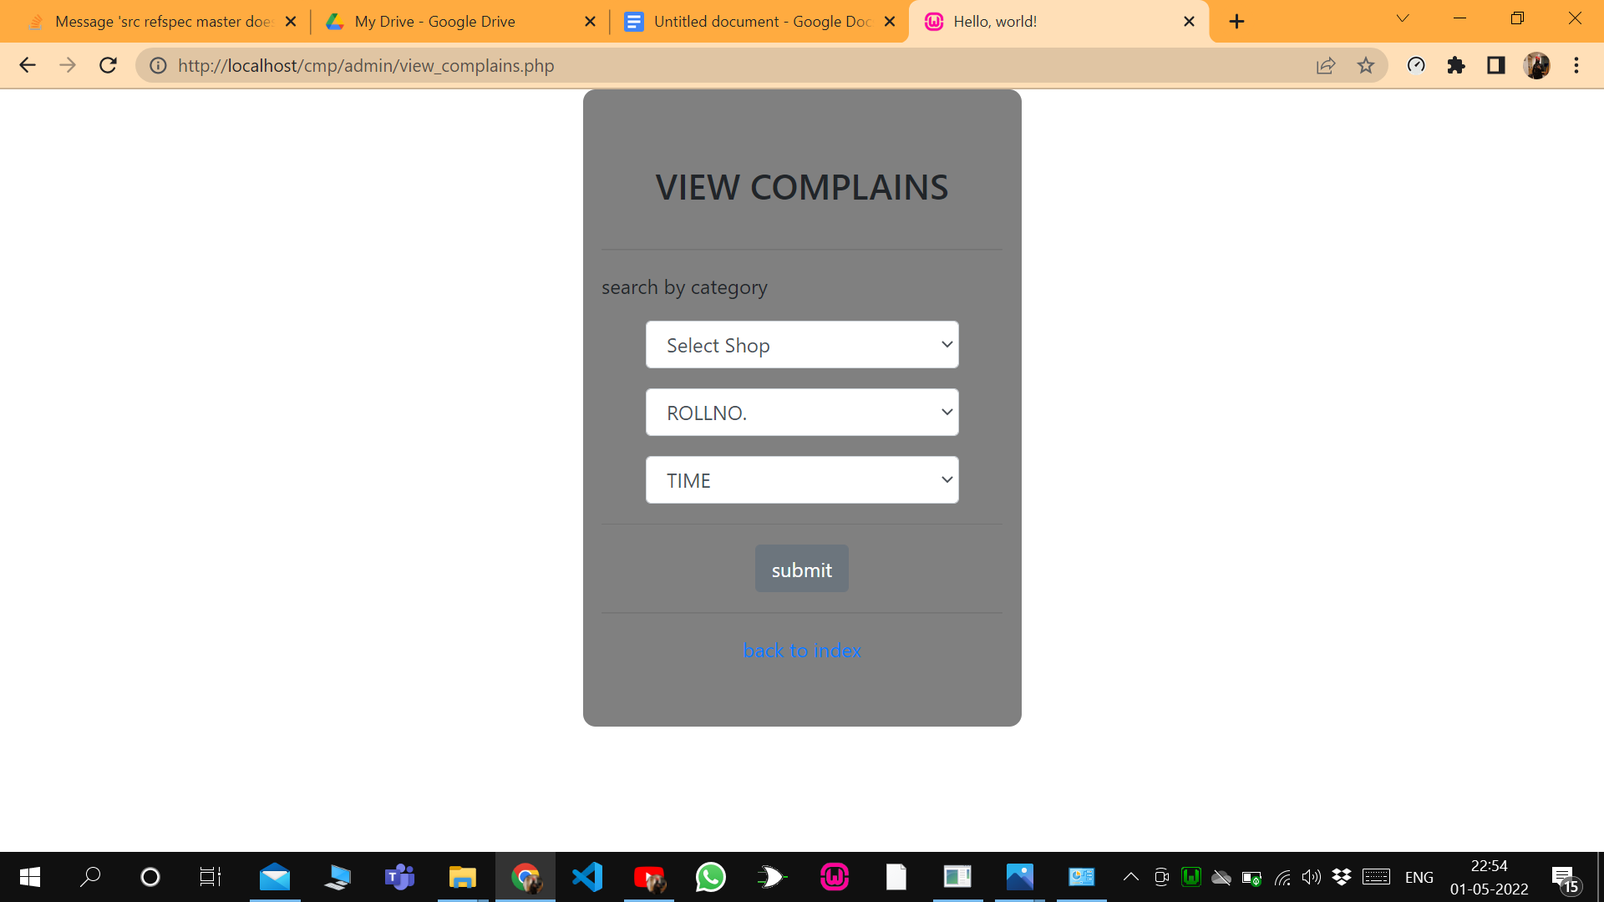
5. Manage users(removing fake users)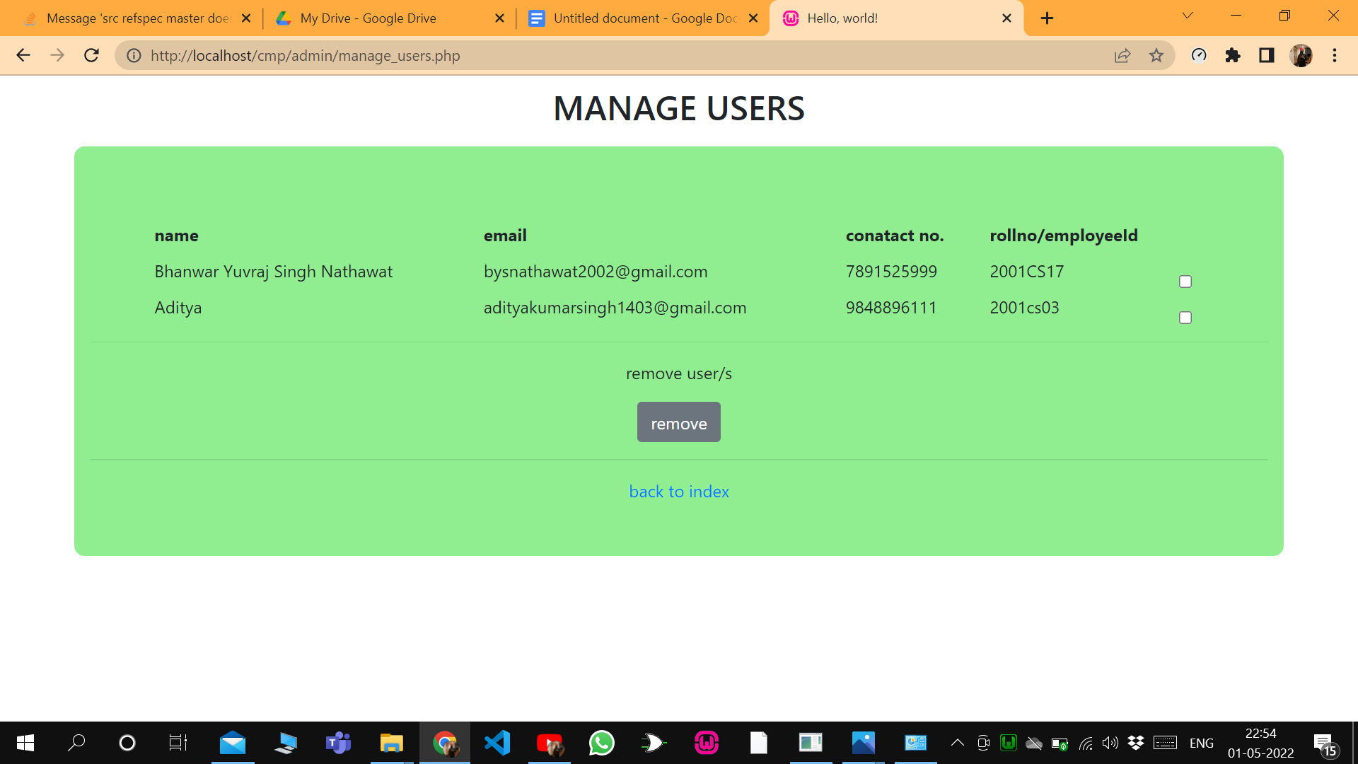
6. Remove complaints (fake ones)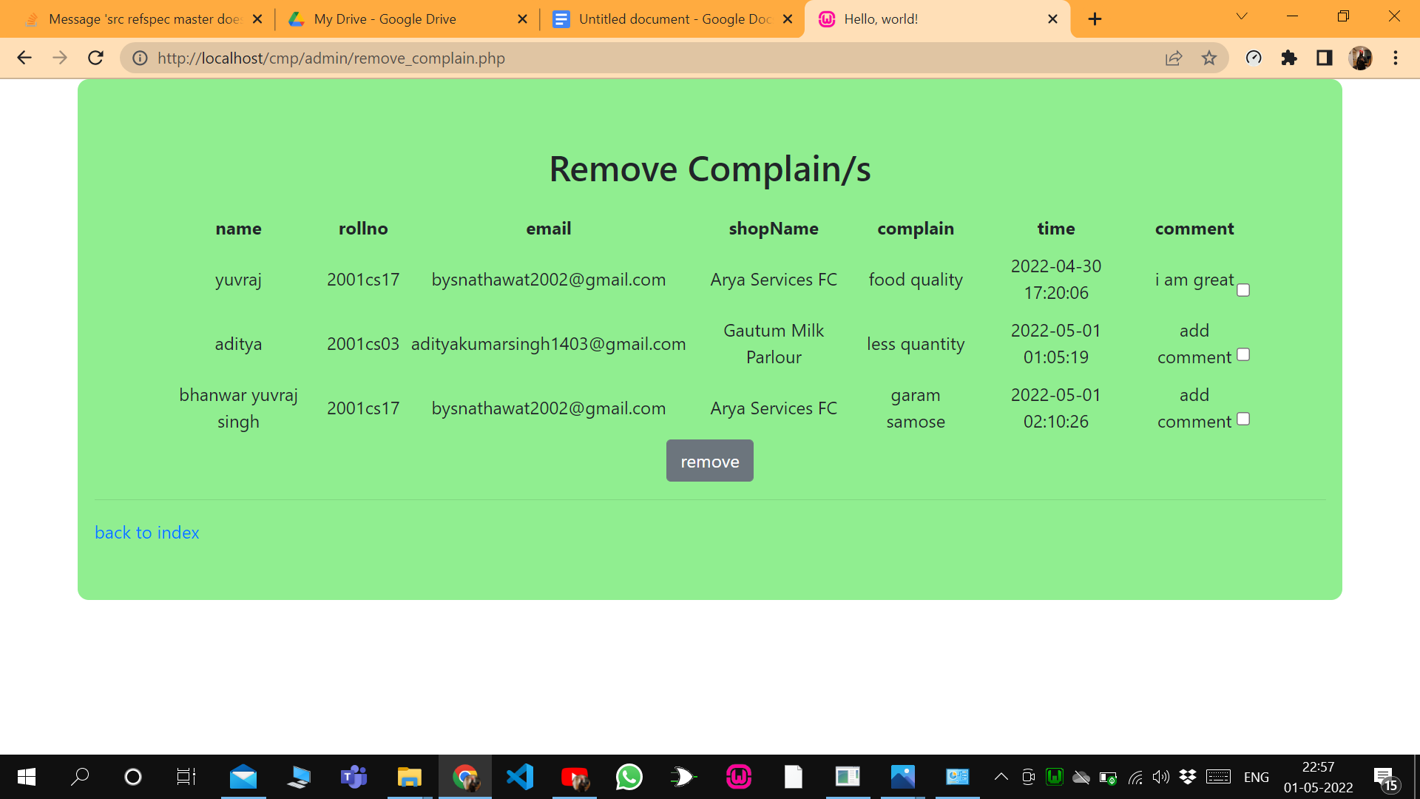
7. Update complains(by adding a comment)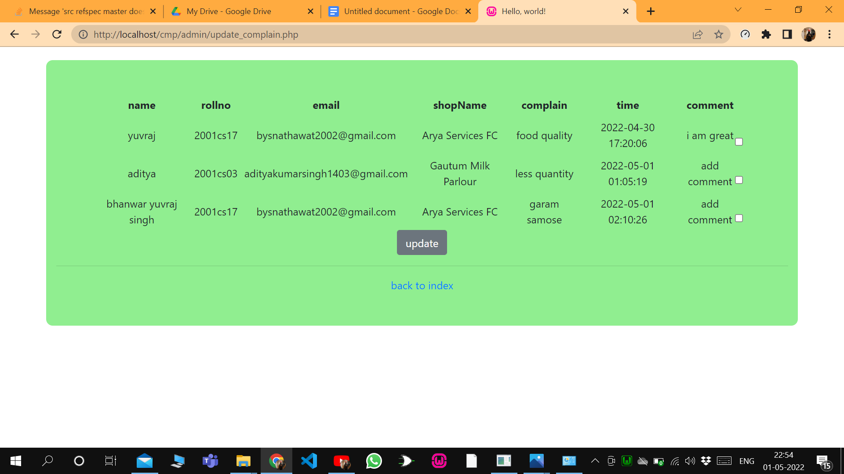
8. Add another admin(admin will not have create account feature on the login page)
9. Add user(for trial or direct complain by admin)

* Features for the shop owner

1. View complaints or his shops(complains selected acc to time and roll..employee id of complainer)
2. Change password
3. Update status of complain(to update the status of complain when it has been resolved)

**Some security features in my portal**

1. You cannot manipulate URL to go to any page without logging in.
2. Also even if users after logging in cannot open the admin portal using URL manipulation because they have different session variables.
3. Once logged , automatically it will log out after 10 min.
4. If anybody forgets his password then there will be an OTP verification via registered Gmail only.
5. You also cannot register using an invalid Gmail.
6. For shop owners, Gmail id should be distinct.
7. Shop owner and admin cannot create their account on their own, only the current admin will have this facility.

Improvements can be:

1. First of all design, it is the most lacked component in my project.
2. User details on the index page.

Future plan:

* I will further add detailing(more features) to the project
* Of course, I will learn CSS and beautify my project.

Code:<https://drive.google.com/drive/folders/13rK2UayOKlkd3cBL4iDYBA9-gd1ZFDez?usp=sharing>